# Module 7 Activity 2: Implementing HTTP Status Codes and Error Handling in Node.jsNode.js on Windows

# Brandon Trinkle

# IFT 458: Middleware Programming

# Professor Dinesh Sthapit

# April 3, 2025

# Module 7 Activity 2: Implementing HTTP Status Codes and Error Handling in Node.jsNode.js on Windows

*Screenshot 1: Of the initialized project structure in your IDE.*

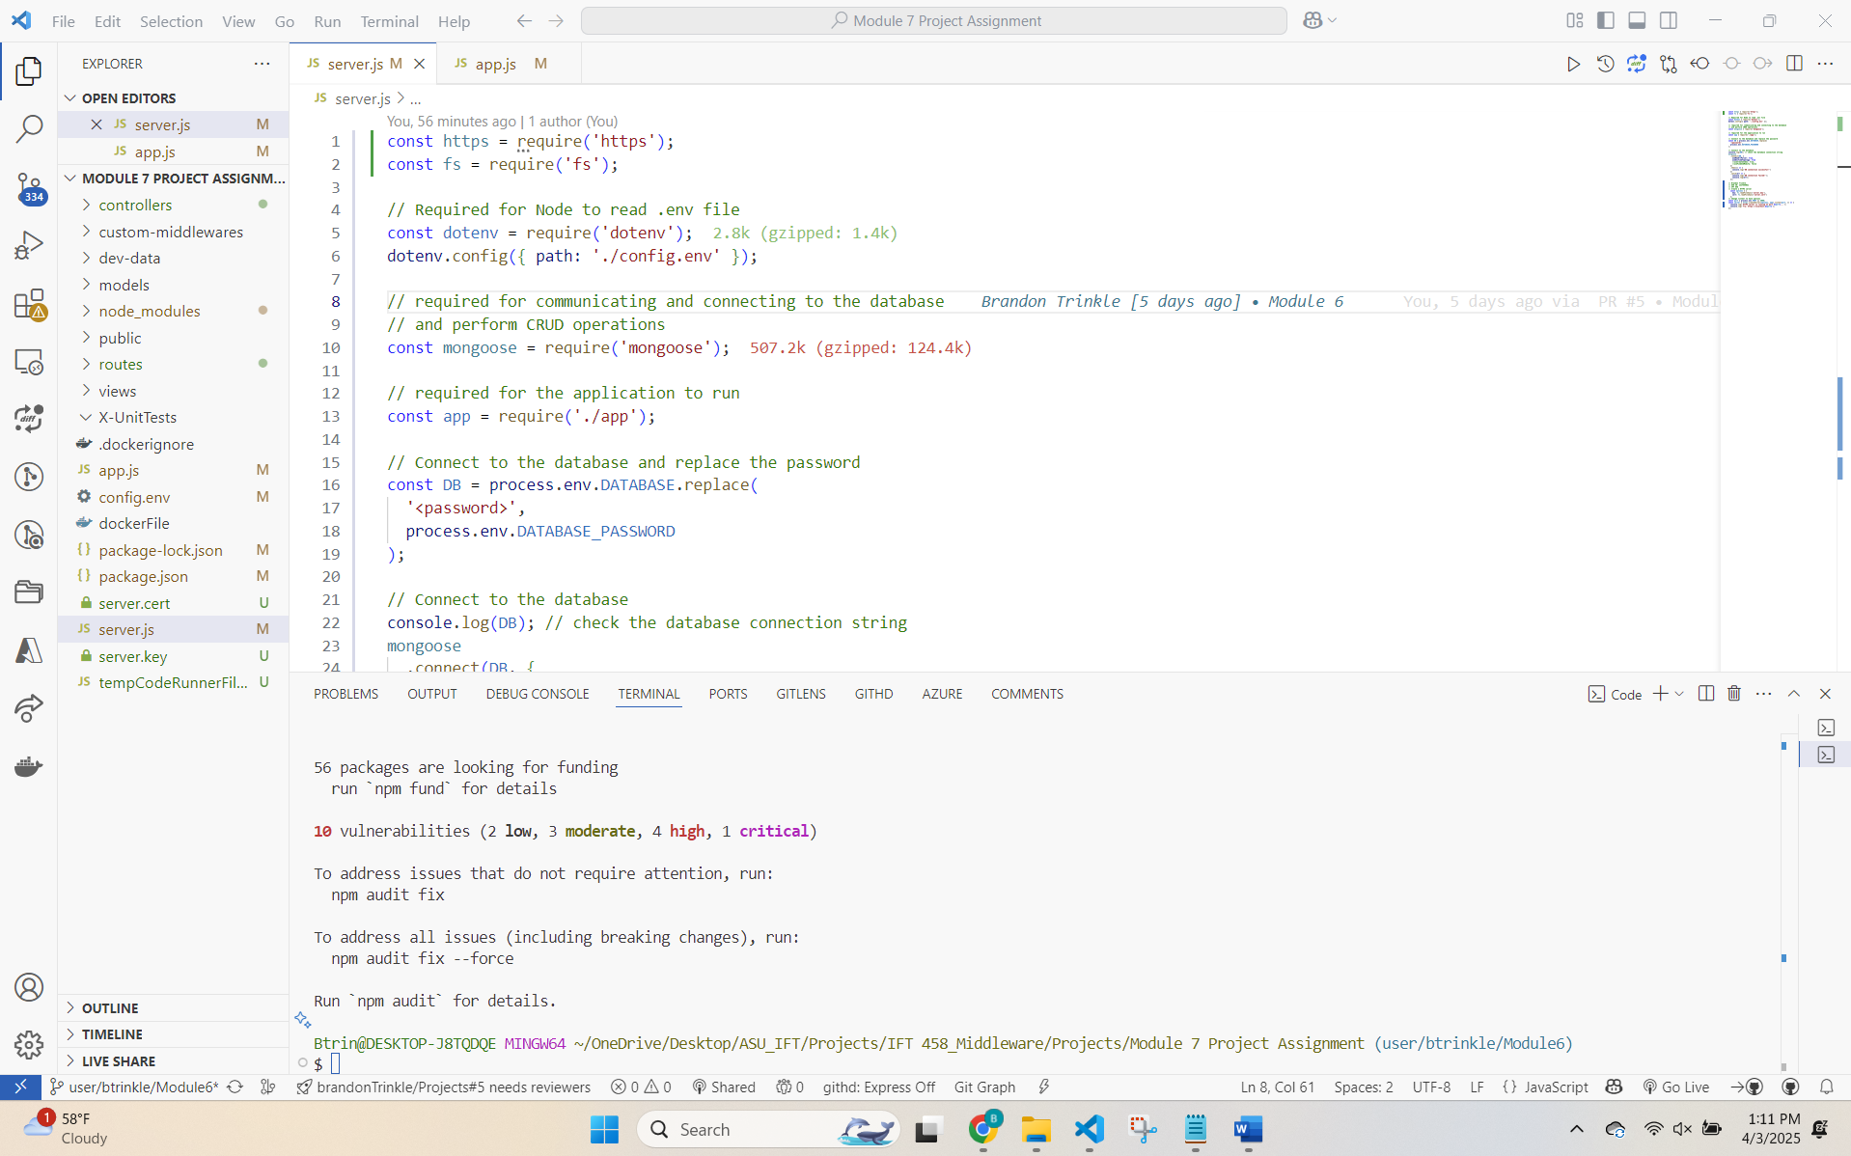

*Screenshot 2: Showing the app.js file with implemented routes for different HTTP status codes.*

*Screenshot 3: Displaying the implemented middleware in app.js for request logging and error handling.*

*Note: 200, 201 and 400 routes  
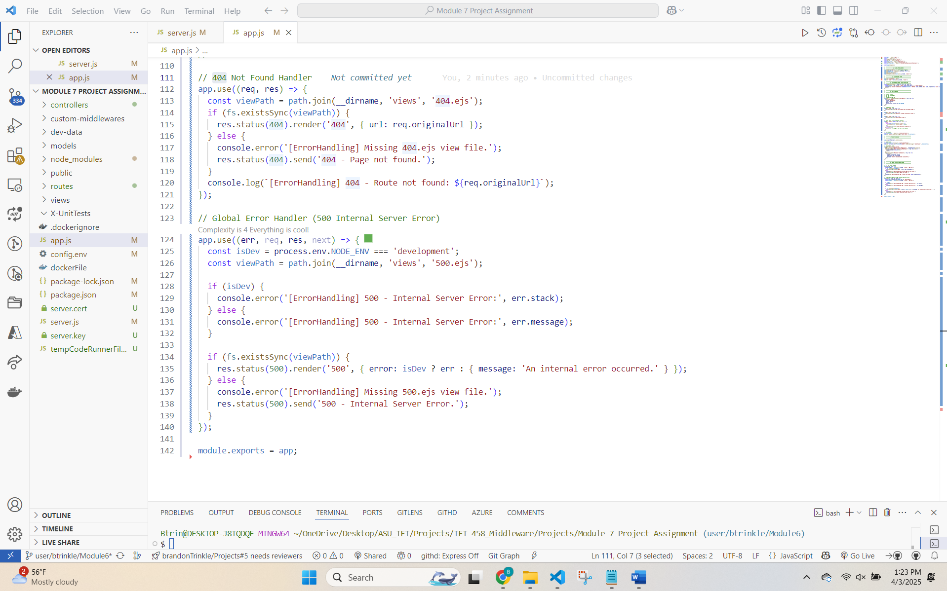*

*Note: 404 & 500*

*Screenshot 4: Of the asynchronous route with try/catch in app.js.*

*Screenshot 5: Showing the running server in the terminal.*

*Note: Error is with .env file specifying api/v1*

*Screenshot 6: Displaying responses from the server for different routes in Postman or a web browser.*

*****Note: Fixed by removing the API version in .env file.*